Jenkins

- How can you implement parallel execution in a Jenkins pipeline?
In a declarative pipeline, use the parallel block to run multiple tasks simultaneously, reducing build time. For example:

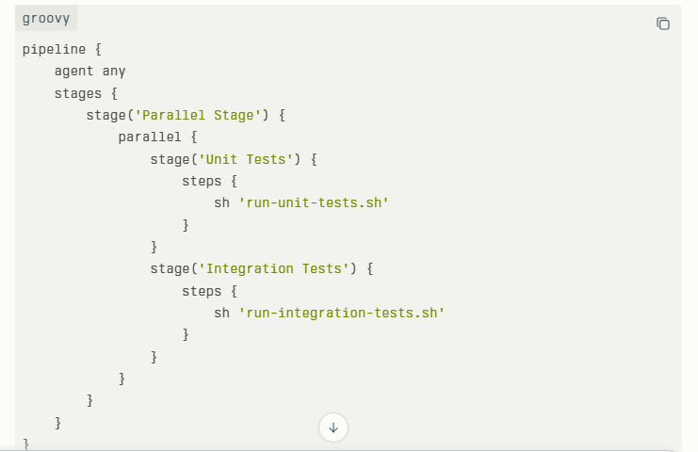

- What are declarative and scripted pipelines?

What are declarative and scripted pipelines? Declarative pipelines have a predefined, simpler structure focusing on readability and maintainability. They use pipeline {} syntax.
Scripted pipelines are written in Groovy with more programming flexibility, allowing complex logic.
Example (Declarative):

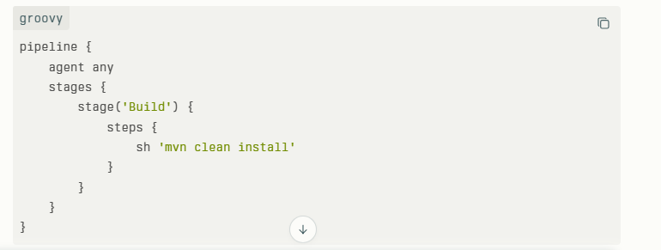

- How do you manage credentials securely in Jenkins?

Jenkins has a built-in credentials store where sensitive data like passwords and tokens are saved securely. You add credentials via Manage Jenkins > Manage Credentials and reference them in jobs using variable bindings.

withCredentials([usernamePassword(credentialsId: 'my-credential-id', usernameVariable: 'USER', passwordVariable: 'PASS')]) {
sh 'curl -u $USER:$PASS https://mysecureapi.example.com'
}

- What is the purpose of the Jenkinsfile and how do you use it?

A Jenkinsfile is a simple text file that holds the step-by-step instructions for automatically building, testing, and delivering your software. It lives in your project’s code repository so the process is always saved, easy to update, and shared with the whole team. Jenkins reads this file to know exactly what to do whenever you want to run your pipeline.

- How can you trigger a Jenkins job from an external source?
To trigger a Jenkins job from an external source, you can use Jenkins' remote build feature. This means you send a special HTTP request (like a web call) to Jenkins, telling it to start a particular job.
Here’s a simple way to do it:
In Jenkins, enable the option "Trigger builds remotely" for the job.
Set a security token (a password-like key) for this trigger.
From an external system or script, send an HTTP request to a URL like:
text
http://jenkins-server/job/job-name/build?token=your-token
Jenkins receives this request and starts the job automatically.
This is helpful when you want to start Jenkins jobs from another tool, a script, or after a code change in a repository.
Example curl command to trigger:
text
curl -X POST http://jenkins-server/job/myjob/build?token=abc123
If your job needs parameters, there are additional URL forms to include them.
This method allows automated, remote control of Jenkins builds without manually clicking in the Jenkins interface. It’s commonly used to integrate Jenkins with other systems and automate workflows easily.
- How do you handle build failures in Jenkins?
-- Analyze build logs to identify errors.
-- Use tools like the “Build Failure Analyzer” plugin.
-- Set up email or Slack notifications on failures.
-- Automate retry strategies or manual intervention workflows.

- How do you create and manage build pipelines in Jenkins?
Pipelines are created using Jenkinsfile with stages and steps. You define stages (e.g., build, test, deploy) and use SCM integration for source control.

- What steps would you take if a Jenkins build is stuck in the queue?
Check resource availability and executor status. Free up or add more executors/nodes as needed.

- How do you optimize Jenkins for large-scale environments?
Use distributed builds with multiple agents, utilize parallel builds, and modularize pipelines using shared libraries to improve efficiency and scalability.

- What is the purpose of Jenkins worker node
A worker node in Jenkins is a separate machine (or server) that runs build jobs assigned by the Jenkins master. It helps distribute work so multiple jobs can run at the same time without overloading the master. This makes Jenkins faster and more scalable. The master controls and schedules the jobs, and the worker node actually executes them. This setup allows using different machines or environments to run builds efficiently.

- What is agent in Jenkins

In Jenkins, an agent is the machine or process that runs the build or automation tasks given by the Jenkins master (controller). It connects to the master and executes jobs such as building code, running tests, or deploying applications. Agents allow Jenkins to distribute work across multiple machines, speeding up the process and enabling parallel execution. Simply put, an agent is the worker that does the actual job under the master’s control.

- Worker node configuration

Step 1: create one worker node (server)

Step 2: Java version should be same in both master and worker-node.

Step 3:

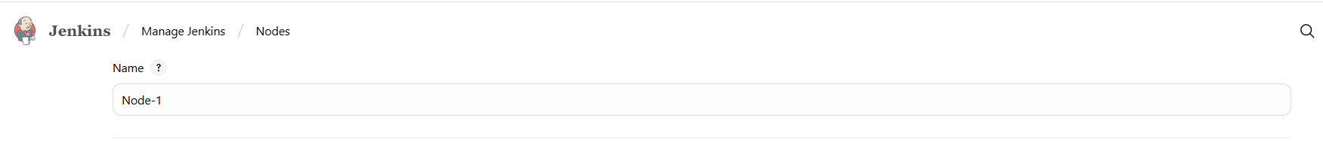

- Here, we have to give the name of node for example: node, worker node

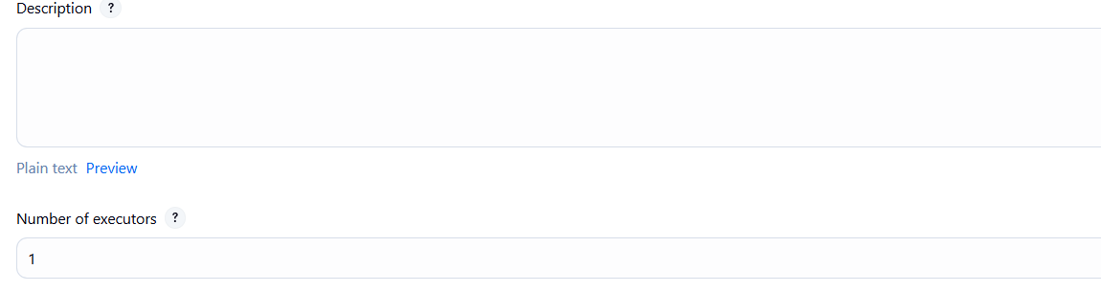
This means parallel how many job should run

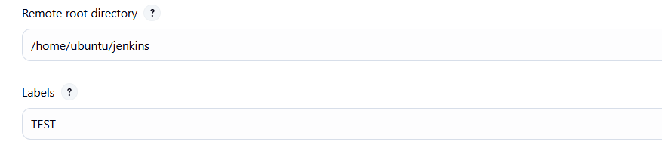
Remote root directory means. We have to create one folder (jenkins) in side server of worker node.

Labels: means which environment pipeline should for example dev ,test,prod. So we can maintain separate pipeline for each environment.
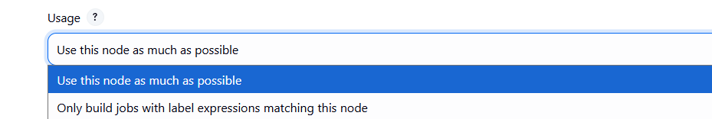

This name itself saying that we can use this node as much as possible or only build jobs with label expression matching this node.

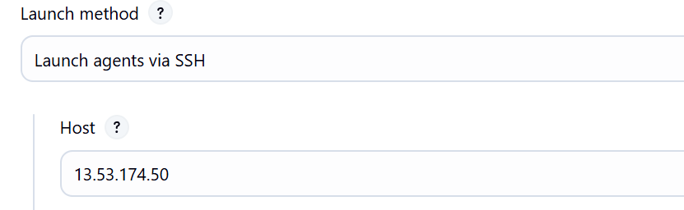

Here we have to mention the private IP address of the worker node server

We have to take the private Ip of the Node server and place it in host.

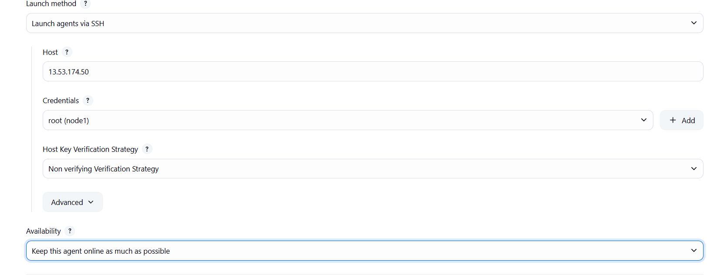

We have to configure the credential part
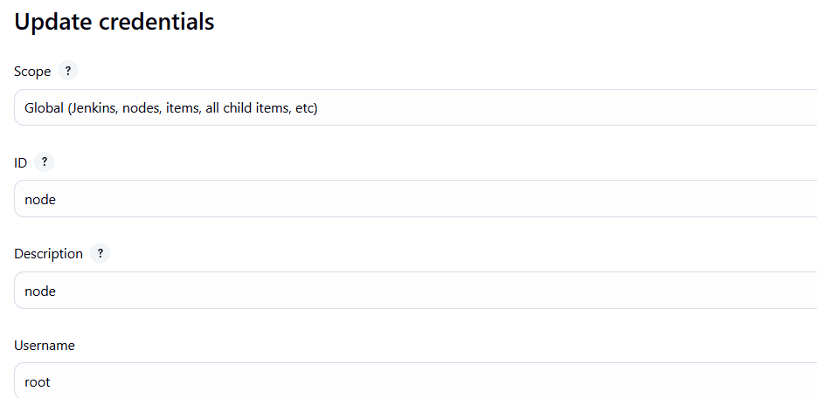

User is root because we have create the jenkins file in node server as a root user

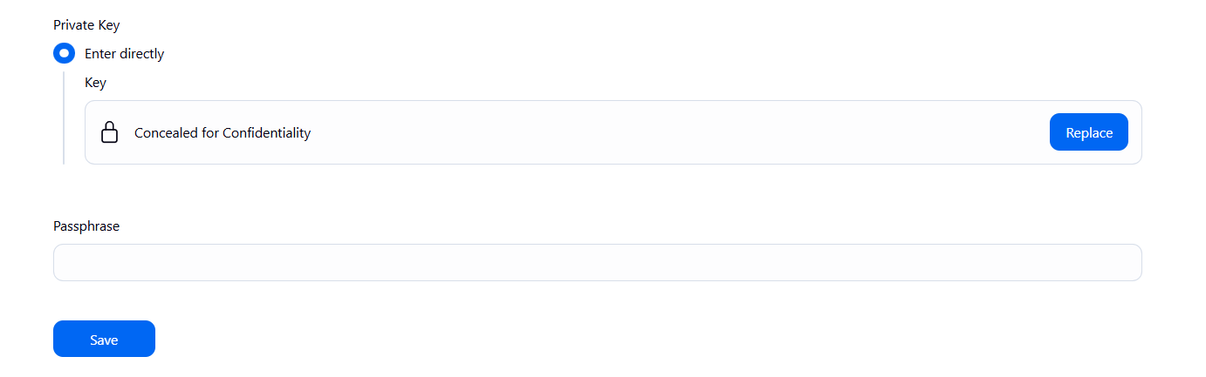

Here , we have to store the private of the worker node .

Note :

We have to mention which node should run . we can create a node for each environment

agent
{
lable: 'Prod'
}

How do you troubleshoot slow Jenkins pipelines?
Identify bottlenecks by analyzing logs, optimizing build steps, using parallel execution, distributing workloads across agents, and cleaning up unnecessary steps or artifacts.

What are some best practices for Jenkins pipeline security?
Use role-based access control, limit script approvals, keep plugins up to date, secure credentials, and run Jenkins with the least privileges necessary.

example of a simple Jenkins pipeline script (Declarative Pipeline) that executes an SQL script on a MySQL database:

pipeline {
agent any
environment {
DB_HOST = 'your-db-host'
DB_NAME = 'your-database'
DB_USER = 'your-username'
DB_PASSWORD = 'your-password'
SQL_SCRIPT = 'scripts/your-script.sql' // Path to the SQL script in your repo
}
stages {
stage('Execute SQL Script') {
steps {
script {
sh """
mysql -h ${DB_HOST} -D ${DB_NAME} -u ${DB_USER} -p${DB_PASSWORD} < ${SQL_SCRIPT}
"""
}
}
}
}
post {
success {
echo 'SQL script executed successfully.'
}
failure {
echo 'SQL script execution failed.'
}
}
}
Explanation for Above command:
DB_HOST is the address of the database server.
DB_NAME is the name of the database where you want to run the script.
DB_USER is the username to log into the database.
DB_PASSWORD is the password for that user.
SQL_SCRIPT is the location (path) of the SQL file you want to execute.

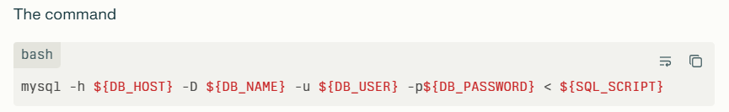

mysql: This runs the MySQL command-line client.
-h ${DB_HOST}: Connect to the MySQL server at the address stored in the variable DB_HOST.
-D ${DB_NAME}: Use the database named in DB_NAME.
-u ${DB_USER}: Connect as the user whose name is in DB_USER.
-p${DB_PASSWORD}: Provide the password stored in DB_PASSWORD to log in.
< ${SQL_SCRIPT}: Take the contents of the SQL script file (from the path in SQL_SCRIPT) as input and execute the SQL commands in it on the specified database.
----------------------------------------------------------------------------------------------------------------------------

To create a pipeline in Jenkins for executing a script in an SQL database, the key plugins required are:

- Pipeline Plugin
Enables defining the pipeline as code (Jenkinsfile) and orchestrating multiple stages including running scripts and handling errors.
2) Git Plugin (or another SCM plugin)
Allows fetching the SQL script and pipeline code from a source code repository like GitHub or GitLab.
3) Credentials Binding Plugin
Securely manages the database credentials (username, password) used in the pipeline without exposing them in plain text.
4)Database Plugin
Provides functionality to connect to the database and execute SQL commands as part of the pipeline steps.
5) Database Driver Plugin (depending on your DB)
For MySQL: MySQL driver/connector (may be installed separately or configured in the environment).
For Microsoft SQL Server: Microsoft SQL Server Database Plugin to support connections and commands execution.
Optional but useful plugins:
Blue Ocean Plugin
For improved visualization and easier pipeline management.
Notification Plugins (Slack, Email, etc.)
For alerting on pipeline success or failure.

To take the SQL script from GitHub and then execute it in the Jenkins pipeline, you need to add a stage to clone or checkout the GitHub repository before the execution stage. Here’s the updated Jenkins pipeline script that includes the Git checkout step:

pipeline {
agent any
environment {
DB_HOST = 'your-db-host'
DB_NAME = 'your-database'
DB_USER = 'your-username'
DB_PASSWORD = 'your-password'
SQL_SCRIPT = 'scripts/your-script.sql' // Path inside the Git repo
GIT_REPO = 'https://github.com/your-username/your-repo.git' // Your GitHub repo URL
GIT_BRANCH = 'main' // Branch to checkout
}
stages {
stage('Checkout GitHub Repo') {
steps {
// Clone the repo to workspace
git branch: "${GIT_BRANCH}", url: "${GIT_REPO}"
}
}
stage('Execute SQL Script') {
steps {
script {
sh """
mysql -h ${DB_HOST} -D ${DB_NAME} -u ${DB_USER} -p${DB_PASSWORD} < ${SQL_SCRIPT}
"""
}
}
}
}
post {
success {
echo 'SQL script executed successfully.'
}
failure {
echo 'SQL script execution failed.'
}
}
}

Explanation:
The Checkout GitHub Repo stage uses the git step to clone the specified GitHub repository and branch into the Jenkins workspace.
The SQL_SCRIPT variable contains the relative path inside this checked-out repository.
The Execute SQL Script stage then runs the SQL script fetched from GitHub against your database.
Make sure Jenkins has the Git plugin installed and that any necessary authentication (like SSH keys or GitHub tokens) is configured if the repo is private.
This will automate pulling the latest SQL script from GitHub and running it in your database as part of your CI/CD pipeline.

